***Hunting Stratus***

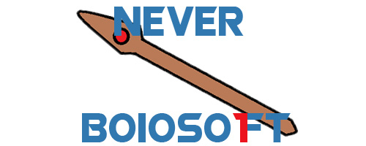

Revision: 0.0.0

GDD Template by Alec Markarian and Benjamin Stanley

Overview

Theme / Setting / Genre

Core Gameplay Mechanics Brief

Targeted platforms

Monetization model (Brief/Document)

Project Scope

Influences (Brief)

- <Influence #1>

- <Influence #2>

- <Influence #3>

- <Influence #4>

The elevator Pitch

Project Description (Brief):

Project Description (Detailed)

What sets this project apart?

Core Gameplay Mechanics (Detailed)

- <Core Gameplay Mechanic #1>

- <Core Gameplay Mechanic #2>

- <Core Gameplay Mechanic #3>

- <Core Gameplay Mechanic #4>

Story and Gameplay

Story (Brief)

Story (Detailed)

Gameplay (Brief)

Gameplay (Detailed)

Assets Needed

- 2D

- 3D

- Sound

- Code

- Animation

Schedule

- <Object #1>

- <Object #2>

- <Object #3>

- <Object #4>

# Overview

## Theme / Setting / Genre

- < Roguevania>

## Core Gameplay Mechanics

- < Random map, keeping a basic structure and districts of the map >

- <Bit of RPG style >

- <Frenzied and dangerous battles >

## Targeted platforms

- <PC>

## Monetization model (Brief/Document)

- <FREE>

## Project Scope

- <Game Time Scale>

- 0$ Budget.

- Undefined time

- <Team Size>

- David López Espada

- Antonio Ruiz Guirao

- <Licenses / Hardware / Other Costs>

- Nothing to pay for about that

- <Total Costs with breakdown>

* Nothing

## Influences (Brief)

### - <Influence #1>

- Metroid, Castlevania, Hollow Knight, Ori

### - <Influence #2>

- Dead Cells, Moonligther, Rogue Legacy

### - <Influence #3>

- Dark Souls, Berserk, Darkwood, Bloodborne

- <Influence #4>

- Spelunky, Isaac, Darkest Dungeon, Hotline Miami

## The elevator Pitch

Roguevania game with tough gameplay and player evolution.

## Project Description (Brief):

<Two Paragraphs at least>

A game where you start as the lowest social rank and you are haunted by high socials ranks (Church, noblece…)

<No more than three paragraphs>

## Project Description (Detailed)

<Four Paragraphs or more If needs be>

A game where you start as the lowest social rank and you are haunted by high socials ranks (Church, noblece…). Every run will start outside the city, you have to break in and arrive to the middle of the city where all the responsable people of the haunting are.

# What sets this project apart?

- <Reason #1>

- Tribute to the genre that did such a great contribution to the videogames and we love

- <Reason #2>

Practice our game development skills

- <Reason #3>

The challenge of making an entire videogame and finish it

## Core Gameplay Mechanics (Detailed)

### - <Core Gameplay Mechanic #1>

- <Details>

### - <Core Gameplay Mechanic #2>

- <Details>

### - <Core Gameplay Mechanic #3>

- <Details>

# Story and Gameplay

## Story (Brief)

## Story (Detailed)

## Gameplay (Detailed)